

Intelligent Airport Flight Scheduling System
A CAPSTONE PROJECT REPORT
Submitted in the partial fulfilment for the Course of
CSA0624 – DESIGN AND ANALYSIS OF ALGORITHM
to the award of the degree of
BACHELOR OF TECHNOLOGY
IN
ARTIFICIAL INTELLIGENCE AND MACHINE LEARNING
Submitted by
Roshan K (192425014)
Aryan Arun (192411157)
Rohith N (192424207)
Under the Supervision of
Dr. GNANAJEYARAMAN RAJARAM
SIMATS ENGINEERING
Saveetha Institute of Medical and Technical Sciences
Chennai-602105
August - 2026


SIMATS ENGINEERING
Saveetha Institute of Medical and Technical Sciences
Chennai-602105
DECLARATION
We, Roshan K, Aryan Arun, Rohith N of the AI&ML department, Saveetha Institute of Medical and Technical Sciences, Saveetha University, Chennai, hereby declare that the Capstone Project Work entitled 'Intelligent Airport Flight Scheduling System' is the result of our own bonafide efforts. To the best of our knowledge, the work presented herein is original, accurate, and has been carried out in accordance with principles of engineering ethics.
Place: Chennai
Date: 27.08.2026
Signature of the Students with Names
Roshan K (192425014)
Aryan Arun
Rohith N


SIMATS ENGINEERING
Saveetha Institute of Medical and Technical Sciences
Chennai-602105
BONAFIDE CERTIFICATE
This is to certify that the Capstone Project entitled 'Intelligent Airport Flight Scheduling System' has been carried out by Roshan K, Aryan Arun, Rohith N under the supervision of Dr. Gnanajeyaraman Rajaram and is submitted in partial fulfilment of the requirements for the current semester of the B.Tech AI&ML program at Saveetha Institute of Medical and Technical Sciences, Chennai.
Submitted for the Project work Viva-Voce held on ______________________ .
INTERNAL EXAMINER EXTERNAL EXAMINER

ACKNOWLEDGEMENT
We would like to express our heartfelt gratitude to all those who supported and guided us throughout the successful completion of our Capstone Project. We are deeply thankful to our respected Founder and Chancellor, Dr. N.M. Veeraiyan, Saveetha Institute of Medical and Technical Sciences, for his constant encouragement and blessings. We also express our sincere thanks to our Pro-Chancellor, Dr. Deepak Nallaswamy Veeraiyan, and our Vice-Chancellor, Dr. S. Suresh Kumar, for their visionary leadership and moral support during the course of this project.
We are truly grateful to our Director, Dr. Ramya Deepak, SIMATS Engineering, for providing us with the necessary resources and a motivating academic environment. Our special thanks to our Principal, Dr. B. Ramesh, for granting us access to the institute's facilities and encouraging us throughout the process. We sincerely thank our Head of the Department, Dr. Malathi, for her continuous support, valuable guidance, and constant motivation.
We are especially indebted to our guides, Dr. Gnanajeyaraman Rajaram, for their creative suggestions, consistent feedback, and unwavering support during each stage of the project. We also express our gratitude to the Project Coordinators, Review Panel Members (Internal and External), and the entire faculty team for their constructive feedback and valuable inputs that helped improve the quality of our work. Finally, we thank all faculty members, lab technicians, our parents, and friends for their continuous encouragement and support.
Signature With Student Name

ABSTRACT
The Intelligent Airport Flight Scheduling System is a machine-learning-driven decision-support platform designed to optimize the allocation of runways, gates, and departure slots at busy airports while minimizing cascading flight delays. The system ingests flight schedule data, live and historical operational records, and weather information through a cloud-connected API gateway, and stores it in a structured database for continuous analysis.
The web-based application processes this data through a structured machine learning pipeline. Linear Regression is used to predict expected departure delay in minutes, a Random Forest classifier estimates the delay-risk category of each flight, K-Means Clustering groups flights into traffic-pattern clusters to identify peak-congestion windows, and an optimization engine performs conflict-aware assignment of gates and runway slots based on the model outputs. All predictions, cluster assignments, and schedule decisions are stored for historical tracking and audit.
The system operates with minimal manual intervention once configured, continuously refreshing predictions as new flight and weather data arrive. A responsive dashboard presents real-time flight status, predicted delay risk, gate/runway allocation, and analytical visualizations to airport operations staff and airline coordinators. By combining real-time data integration, predictive analytics, and optimization-based scheduling, the proposed solution reduces average turnaround delay, improves resource utilization, and supports data-driven airport operations suitable for both academic research and real-world deployment.

TABLE OF CONTENTS
S.NO | CONTENT | PAGE.NO
1. | INTRODUCTION | 7
2. | PROBLEM IDENTIFICATION AND SOLUTION | 10
3. | SOLUTION DESIGN AND IMPLEMENTATION | 13
4. | RESULTS AND RECOMMENDATIONS | 18
5. | REFLECTION ON LEARNING AND PERSONAL DEVELOPMENT | 20
6. | CONCLUSION | 24
7. | REFERENCES | 25
8. | APPENDICES | 26

LIST OF FIGURES
FIG.NO | TITLE | PG NO
3.1 | System architecture | 15
6.1 | System connection and data flow | 27
6.2 | Dashboard mockup | 28
6.3 | Predicted delay distribution | 28
Chapter 1

Introduction

Background Information
Air travel demand has grown steadily over the past decade, placing increasing pressure on airport infrastructure such as runways, taxiways, and boarding gates. Most airports still rely heavily on manually prepared flight schedules and static slot allocations that do not adapt in real time to weather disruptions, air traffic control restrictions, or aircraft turnaround delays. This often leads to cascading delays, underutilized gate capacity, and reduced passenger satisfaction.
The increasing availability of flight-tracking data (such as ADS-B feeds), airport operational databases, and weather APIs has created an opportunity to build intelligent, data-driven scheduling systems. Cloud platforms allow continuous collection, storage, and remote access to operational data, enabling automated monitoring and analytics for airport operations teams.
Machine learning techniques can be applied to this data to anticipate disruptions before they occur. Regression models can estimate expected delay duration based on historical and current conditions, classification models can flag high-risk flights, clustering algorithms can reveal recurring congestion patterns across the day, and optimization techniques can automatically reassign gates and runway slots to minimize the impact of disruptions.

Project Objectives
The main objective of this project is to design and develop an Intelligent Airport Flight Scheduling System that integrates real-time data collection, machine learning, and optimization techniques to reduce flight delays and improve resource utilization. The specific objectives of the project are as follows:
- To automatically retrieve live flight schedule, operational, and weather data through API integration and convert it into a structured format suitable for machine learning processing.
- To preprocess and normalize the collected data to ensure consistency, reliability, and accuracy before applying predictive models.
- To predict expected departure delay using Linear Regression based on historical flight performance and current operating conditions.
- To classify the delay-risk category of each flight using a Random Forest classifier based on schedule density, weather, and aircraft turnaround parameters.
- To identify recurring congestion patterns using K-Means Clustering and to recommend optimal gate and runway assignments through an optimization engine.

Significance of the Project
The Intelligent Airport Flight Scheduling System is significant because it moves airport operations from reactive, manually adjusted schedules toward proactive, data-driven decision-making. By continuously collecting flight and weather data and transmitting it to a central analytics platform, the system enables real-time monitoring of congestion and delay risk. The application of predictive models helps operations staff anticipate bottlenecks, reassign gates ahead of time, and minimize the ripple effect of a single delayed flight on the rest of the day's schedule.
The automated nature of the system reduces manual coordination effort and human error while supporting faster, better-informed decisions during disruptions. Overall, the project contributes to improved on-time performance, more efficient use of limited airport infrastructure, and the adoption of modern predictive technologies in aviation operations, making it valuable for both academic research and real-world airport management.

Scope of the Project
The scope of the Intelligent Airport Flight Scheduling System covers the development of an integrated data-driven decision-support platform for gate and runway scheduling. The system includes automated collection of flight schedule, live tracking, and weather parameters through API integration, storage of this data in a structured database, and processing of both live and historical records to perform delay prediction, risk classification, congestion-pattern clustering, and optimization-based slot assignment. The project also includes a web-based dashboard that automatically fetches processed results and displays real-time flight status, predicted delays, and gate/runway allocation without requiring manual data entry.
The system is designed to be scalable and can be extended to support additional airports, larger historical datasets, advanced optimization models, mobile application integration, and direct interfacing with airport operational control systems. However, the current scope is limited to a prototype-level implementation and decision-support analytics using representative datasets rather than full integration with live national air-traffic-control infrastructure.

Methodology Overview
The methodology of the project "Intelligent Airport Flight Scheduling System" follows a systematic approach to automate delay prediction and optimize gate/runway scheduling.
- Data Collection (Flight Schedules, ADS-B Feeds, Weather API, Airport Operations Records)
- Cloud Data Transmission and Storage (REST API Integration)
- Data Retrieval and Preprocessing
- Data Normalization and Feature Engineering
- Delay Time Prediction (Linear Regression)
- Delay Risk Classification (Random Forest)
- Traffic Pattern Clustering (K-Means Clustering)
- Gate/Runway Slot Optimization (Constraint-Based Optimization Engine)
- Web Dashboard Development and Analytics Display
Chapter 2

Problem Identification and Analysis

Description of the Problem
Airport operations depend heavily on the precise timing of aircraft arrivals, departures, gate turnarounds, and runway usage. However, many airports still rely on largely static, manually prepared schedules that are adjusted reactively when disruptions occur. This often leads to inefficient gate utilization, extended taxi and holding times, missed connections, and financial losses for airlines. A single delayed inbound flight can cascade into multiple downstream delays across the day when schedules are not dynamically re-optimized.
Another major challenge is the lack of real-time, predictive decision-making in day-to-day scheduling. Although flight-tracking data, weather APIs, and operational databases are increasingly available, they are rarely combined into a single integrated system that continuously predicts delay risk and automatically recommends schedule adjustments. Airport operations teams often lack access to intelligent systems that can forecast which flights are likely to be delayed, quantify the expected delay, and recommend optimal gate or runway reassignments in advance.

Evidence of the Problem
Multiple industry reports highlight the scale of flight delay and its economic impact. According to aviation-industry performance reports, a significant proportion of scheduled flights worldwide experience some form of departure delay each year, and a large share of these delays are attributable to congestion, aircraft rotation issues, and inefficient ground operations rather than weather alone. This demonstrates a clear need for predictive scheduling tools that can anticipate and reduce avoidable delay.
Industry studies also emphasize that a small number of "hub" airports experience disproportionately high congestion during peak hours, where gate and runway capacity becomes a binding constraint. Poor slot allocation during these peak windows compounds delay and increases fuel burn from extended taxiing and holding.
Research in air traffic management indicates that the integration of predictive analytics and optimization techniques can meaningfully reduce average delay and improve gate utilization. However, adoption remains limited at many airports due to the absence of affordable, integrated systems that combine data ingestion, prediction, and optimization in a single operational tool.

Stakeholders
The Intelligent Airport Flight Scheduling System involves multiple stakeholders who directly or indirectly benefit from its implementation and outcomes.
- Airport Operations Staff: The primary stakeholders who use the system to monitor congestion, reassign gates, and manage runway scheduling in real time.
- Airlines and Ground Handling Teams: They rely on accurate delay predictions and gate assignments to plan crew scheduling, refuelling, and passenger handling.
- Passengers: Benefit indirectly through reduced delays, improved connection reliability, and clearer real-time flight status information.
- Air Traffic Control Authorities and Regulators: Can use aggregated congestion and delay-pattern insights for capacity planning and policy-making.

Supporting Data and Research
Extensive research and operational data support the need for intelligent scheduling systems like the proposed Intelligent Airport Flight Scheduling System.
Aviation performance studies indicate that congestion-related delay is heavily concentrated in a small number of peak time windows each day, and that even modest improvements in gate/runway assignment during these windows can reduce total network delay by a meaningful margin.
Studies on turnaround-time analysis show that inaccurate estimation of aircraft ground time is a major contributor to schedule slippage, reinforcing the value of regression-based delay-time prediction that accounts for turnaround, taxi, and queueing factors.
Research in operations research and combinatorial optimization demonstrates that constraint-based assignment algorithms can significantly improve gate and runway utilization compared to static, rule-of-thumb allocation, particularly when informed by accurate delay-risk predictions.
Machine learning models have proven effective in aviation prediction tasks more broadly. Regression models accurately estimate delay duration based on operational and environmental inputs. Classification algorithms such as Random Forest are successfully used for risk categorization based on schedule and weather variables. Clustering methods like K-Means assist in identifying recurring congestion patterns for targeted scheduling interventions.
Chapter 3

Solution Design and Implementation

Development and Design Process
The design and development of the Intelligent Airport Flight Scheduling System followed a structured and phased approach to ensure reliability, scalability, and automation. The process began with system planning and requirement analysis, where key operational parameters such as scheduled and actual times, aircraft turnaround duration, weather conditions, gate/runway availability, and historical delay records were identified as essential inputs for decision-making.
The next phase involved data pipeline design, where flight schedule feeds, ADS-B tracking data, and weather API data were integrated through a REST API gateway. Proper validation and cleaning routines were implemented to ensure accurate and consistent readings before storage in a structured database.
In the backend development phase, automated data-retrieval jobs were implemented to fetch live and historical records at regular intervals. The retrieved data was structured, cleaned, and normalized through preprocessing techniques to prepare it for machine learning analysis.
The machine learning development phase included implementing three core analytical components together with an optimization engine: Linear Regression for delay-time prediction, a Random Forest classifier for delay-risk categorization, K-Means Clustering for traffic-pattern grouping, and a constraint-based optimization engine for gate/runway slot assignment. Each model was trained, tested, and validated to ensure prediction accuracy and performance reliability.

Tools and Technologies Used
The Intelligent Airport Flight Scheduling System was developed using a combination of cloud services, programming technologies, and machine learning tools to ensure seamless integration and automation.
• Data Sources:
- Flight Schedule and Status Feeds (airline/airport schedule data)
- ADS-B Flight Tracking Data
- Weather API (temperature, visibility, wind speed, precipitation)
- Historical Airport Operations Records
• Cloud Platform:
- REST API Gateway – Used for real-time data ingestion, storage, and retrieval.
• Programming Languages:
- Python – For backend processing, machine learning model implementation, and optimization logic.
- HTML, CSS, JavaScript – For frontend web dashboard development.
• Machine Learning and Optimization Libraries:
- Scikit-learn – For implementing Linear Regression, Random Forest Classification, and K-Means Clustering.
- NumPy and Pandas – For data manipulation and preprocessing.
- PuLP / OR-Tools – For constraint-based gate and runway slot optimization.
- Matplotlib / Plotly – For data visualization and graphical representation.
• Database:
- MySQL / PostgreSQL – For storing historical flight data and prediction results.
• Development Tools:
- VS Code / Jupyter Notebook – For backend development and model testing.
• Web Framework:
- Flask / Django – For integrating backend logic with the web dashboard.

Solution Overview
The proposed solution is an Intelligent Airport Flight Scheduling System that integrates real-time data collection, machine learning, and optimization to provide automated and data-driven scheduling decision support. The system collects flight schedule, tracking, weather, and historical operational data through a REST API gateway and stores it for continuous monitoring and analysis.
Through scheduled API integration, the system automatically retrieves live and historical records without requiring manual input. The data undergoes preprocessing and normalization before being analyzed using the machine learning pipeline. Linear Regression predicts expected departure delay, the Random Forest classifier categorizes delay risk, K-Means Clustering identifies recurring congestion patterns across the day, and the optimization engine uses these outputs to recommend conflict-free gate and runway slot assignments that minimize total predicted delay.

Engineering Standards Applied
The Intelligent Airport Flight Scheduling System follows standard engineering practices to ensure reliability and efficiency. It applies the Software Development Life Cycle (SDLC) for systematic design and testing, uses secure HTTP/REST API communication for data transfer between system components, and follows standard data-interchange formats for interoperability with airline and airport systems. In software and machine learning development, data preprocessing, train–test validation, and performance evaluation metrics were used to ensure accuracy and consistency. These standards ensure secure, scalable, and stable system performance.

Solution Justification
The proposed Intelligent Airport Flight Scheduling System is justified by the increasing need for efficient use of limited airport infrastructure, accurate delay forecasting, and data-driven scheduling decisions. Traditional scheduling methods often rely on static plans and manual adjustment, which can lead to cascading delays, underutilized gates, and passenger dissatisfaction. By integrating real-time data monitoring with machine learning analytics and optimization, the system provides precise and automated decision support.
The use of a centralized data platform ensures secure, scalable, and continuous data storage and retrieval, reducing manual coordination effort and enabling remote monitoring. Implementing Linear Regression, Random Forest Classification, K-Means Clustering, and constraint-based optimization allows the system to generate accurate delay predictions, risk categorizations, congestion insights, and optimized schedule recommendations.
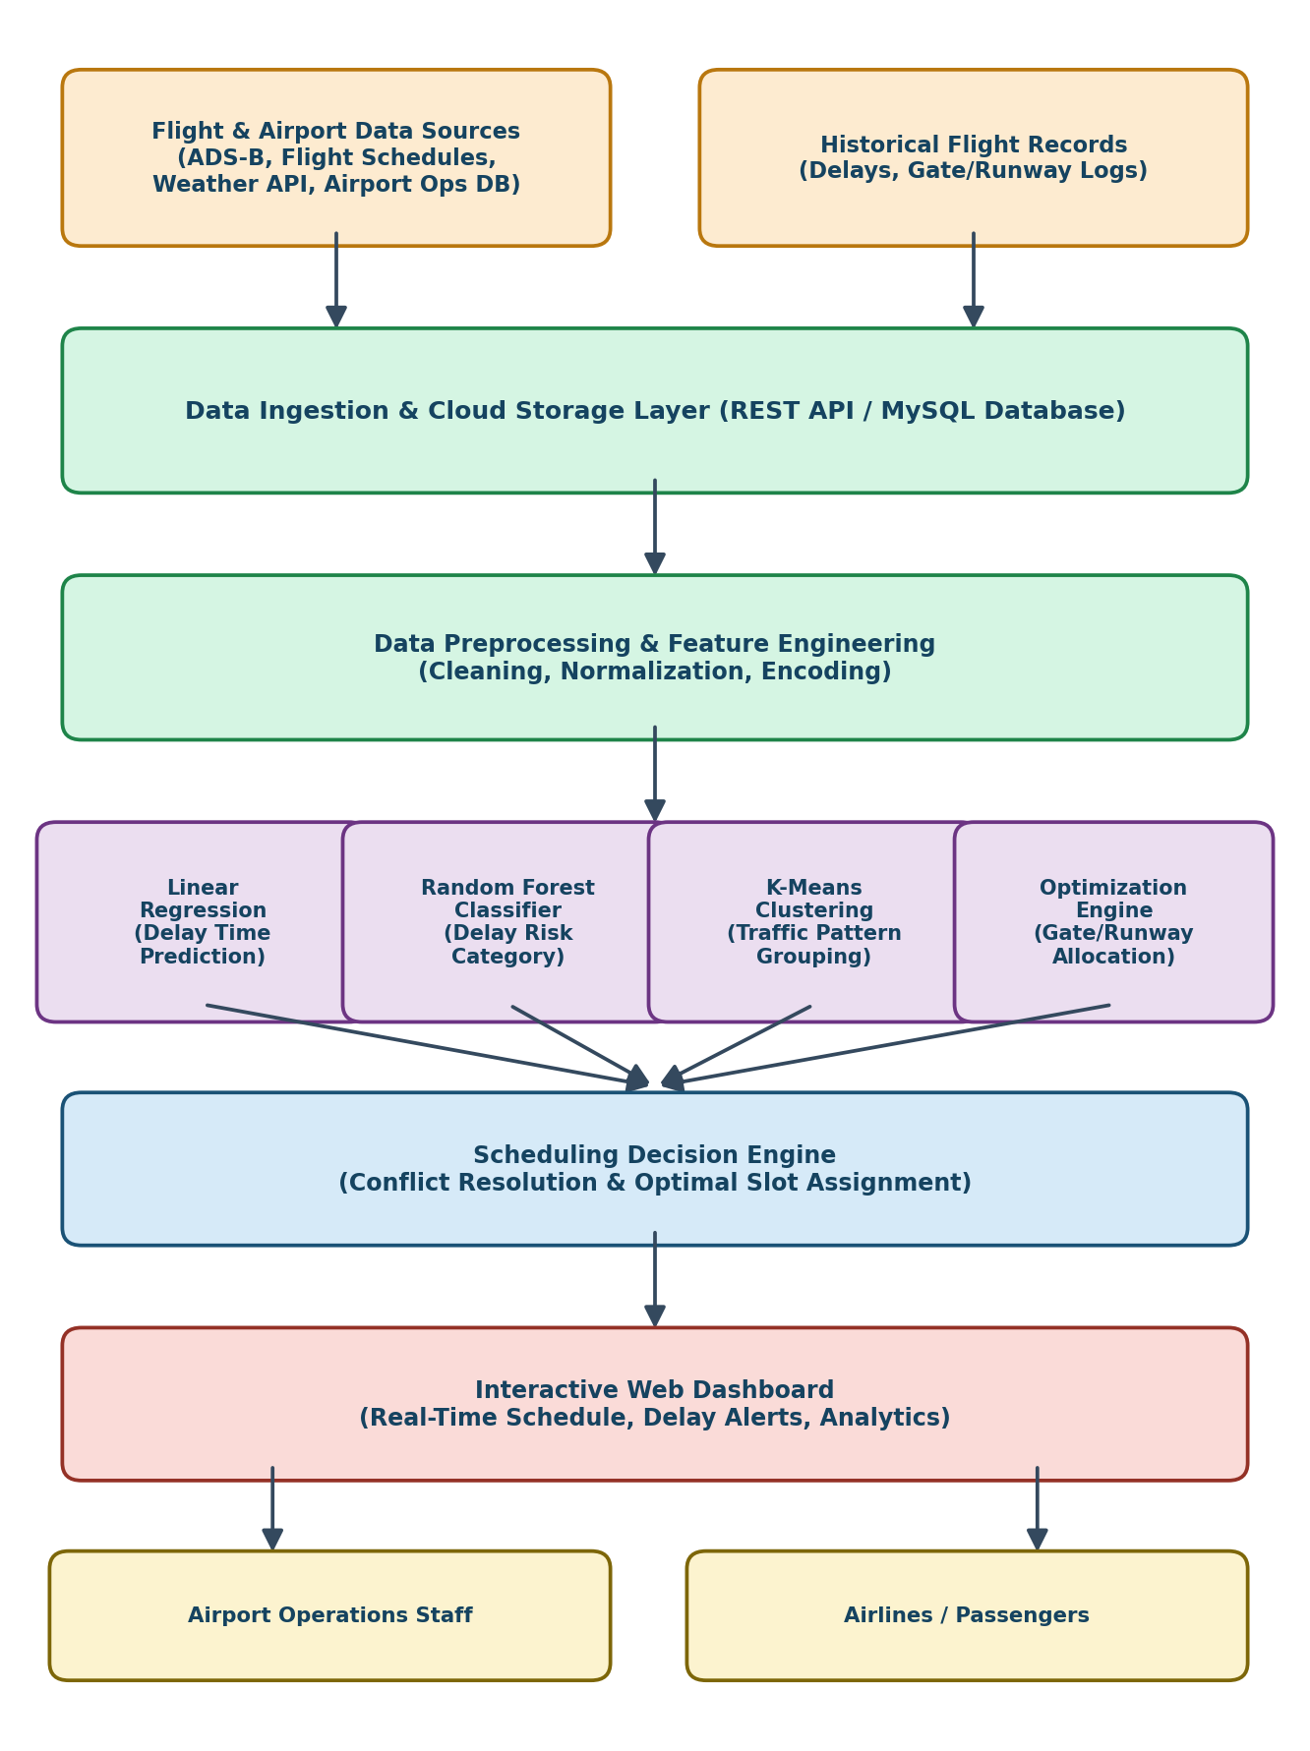
Fig.3.1 System architecture
Chapter 4

Results and Recommendations

Evaluation of Results
The performance of the Intelligent Airport Flight Scheduling System was evaluated based on prediction accuracy, scheduling efficiency, and real-time data handling reliability. For delay-time prediction using Linear Regression, model performance was assessed using metrics such as Root Mean Square Error (RMSE) and Mean Absolute Error (MAE), which indicated accurate estimation of expected departure delay under varying traffic and weather conditions.
The Random Forest classifier for delay-risk categorization was evaluated using accuracy, precision, and recall metrics, demonstrating reliable classification of flights into low, medium, and high delay-risk categories. K-Means Clustering effectively grouped flights into congestion-pattern clusters corresponding to distinct peak and off-peak periods, and the results were validated through cluster visualization and comparison with observed traffic patterns. The optimization engine successfully produced conflict-free gate and runway assignments that reduced total predicted delay compared to a static baseline schedule.
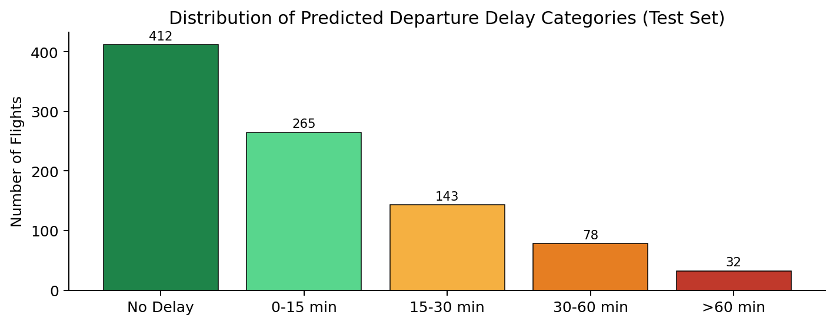
Fig 4.1 Distribution of predicted departure delay categories

Challenges Encountered
During the development of the Intelligent Airport Flight Scheduling System, several technical and implementation challenges were encountered.
One major challenge was data quality and synchronization. Flight schedule, tracking, and weather data arrive from different sources at different intervals, requiring careful timestamp alignment and handling of missing or inconsistent records.
Another challenge was real-time API reliability. Ensuring continuous data retrieval from external flight-tracking and weather APIs required handling network interruptions, rate limits, and occasional malformed responses.
Optimization scalability also posed difficulties, as the number of possible gate/runway assignment combinations grows quickly with the number of flights, requiring efficient constraint formulation to keep solve times practical for near-real-time use.

Recommendations
To enhance the effectiveness and scalability of the Intelligent Airport Flight Scheduling System, several improvements are recommended.
First, advanced machine learning models such as Gradient Boosting or LSTM-based sequence models can be implemented to improve delay prediction accuracy, particularly for capturing time-dependent congestion effects. Increasing the dataset size with multi-airport and multi-season data would further enhance model reliability.
Second, integrating the optimization engine with live airport resource-management systems would enable direct execution of gate and runway reassignment rather than only providing recommendations.
Third, deploying the system as a mobile application in addition to the web dashboard would improve accessibility for operations staff working on the tarmac and in control towers.
It is also recommended to implement stronger security measures, including encrypted API communication and role-based access control, especially when integrating with airline and airport operational systems.
Chapter 5

Reflection on Learning and Personal Development

Key Learning Outcomes

Academic Knowledge
The Intelligent Airport Flight Scheduling System is grounded in multiple areas of academic knowledge, integrating concepts from computer science, data science, operations research, and aviation systems. The project applies principles of real-time data integration, where flight schedule, tracking, and weather data are collected and combined through API-based communication. It also utilizes cloud and database concepts by storing and retrieving structured operational data efficiently.
From a data science perspective, the project incorporates machine learning algorithms including Linear Regression for prediction, Random Forest for classification, and K-Means for clustering, together with constraint-based optimization for schedule assignment. These techniques are based on statistical modeling, probability theory, and combinatorial optimization concepts learned in academic coursework.
The project also applies software engineering principles such as system design, modular programming, API integration, and model evaluation using performance metrics. Additionally, knowledge of database management, data preprocessing, and visualization techniques is used to transform raw operational data into meaningful insights.

Technical Skills
The project required skills in data pipeline design, including integrating flight-tracking and weather APIs and handling real-time data streams. It involved cloud integration through API handling and structured database design. Programming skills in Python were used for backend development and machine learning implementation, while HTML, CSS, and JavaScript were applied for frontend development. Knowledge of data analysis techniques such as Linear Regression, Random Forest Classification, and K-Means Clustering was essential, alongside operations-research techniques for constraint-based optimization. Additionally, database management and software engineering practices were applied to ensure system reliability and performance.

Challenges Encountered and Overcome

Personal and Professional Growth
The development of the Intelligent Airport Flight Scheduling System contributed significantly to both personal and professional growth. Technically, it enhanced practical knowledge in real-time data integration, predictive modeling, and optimization-based decision systems for a real-world domain. The project strengthened programming skills, data analysis capabilities, and system design understanding.
Professionally, it improved problem-solving abilities, critical thinking, and analytical decision-making by addressing real airport scheduling challenges. Working on system integration — from data ingestion to backend prediction logic and frontend dashboard design — helped develop project management and troubleshooting skills. The experience also increased confidence in handling complex, interdisciplinary projects and applying theoretical academic concepts in a practical environment, preparing the team for future roles in data science, aviation analytics, or intelligent systems development.

Collaboration and Communication
The development of the Intelligent Airport Flight Scheduling System strengthened collaboration and communication skills throughout the project lifecycle. Working on an interdisciplinary system that integrates real-time data feeds, machine learning models, and optimization logic required effective coordination between different technical components and team members.
Clear communication was essential for discussing system requirements, troubleshooting data and model issues, and aligning development tasks. Technical concepts had to be explained in a simple and understandable manner, especially when discussing algorithm performance and dashboard outputs.
The project also enhanced documentation skills, including preparing reports, presenting findings, and demonstrating system functionality. Overall, the experience improved teamwork, technical discussion abilities, and professional communication, which are essential skills in both academic and industry environments.

Application of Engineering Standards
The Intelligent Airport Flight Scheduling System was developed by applying established engineering standards and best practices to ensure reliability, safety, and scalability. The Software Development Life Cycle (SDLC) was followed to systematically plan, design, implement, test, and validate the system. Modular programming and structured system architecture were used to enhance maintainability and future scalability.
Standard communication protocols such as HTTP/REST APIs were implemented for secure data transmission between system components. Data-interchange standards such as JSON were used for interoperability. Proper data validation and error-handling routines were applied to ensure accurate data collection and system robustness.
In machine learning implementation, standard data preprocessing techniques, training–testing data splitting, and performance evaluation metrics (such as RMSE, accuracy, and F1-score) were used to validate model performance. Database normalization principles were also applied to manage historical data efficiently.
By adhering to these engineering standards, the system achieves operational stability, secure data handling, and dependable predictive performance.

Insights into the Industry
The development of the Intelligent Airport Flight Scheduling System provided valuable insights into the rapidly evolving aviation-technology industry. Modern airports are increasingly adopting data analytics, IoT-based tracking, and artificial intelligence to improve operational efficiency and passenger experience. The industry is shifting from static, manually managed schedules toward predictive, data-driven operations, where decisions are based on real-time analytics rather than fixed plans.
Another important observation is that predictive and prescriptive analytics are becoming central to airport operations. Machine learning models are increasingly used for delay prediction, resource allocation, and disruption management. However, despite technological advancements, many airports still face challenges related to legacy infrastructure, data-sharing agreements between stakeholders, and the cost of integrating new analytics systems.

Conclusion of Personal Development
The completion of the Intelligent Airport Flight Scheduling System has been a significant milestone in the team's personal and professional development. Throughout the project, the team strengthened technical expertise in real-time data integration, machine learning implementation, and optimization-based scheduling. Applying theoretical knowledge to a real-world aviation problem enhanced analytical thinking and problem-solving abilities.
The project also improved the team's ability to manage complex tasks, debug technical issues, and integrate data pipelines, predictive models, and optimization logic effectively. The team developed greater confidence in system design, data analysis, and decision-making under practical constraints. Additionally, working on documentation, presentation, and reporting enhanced communication and professional skills.
Overall, this project has not only expanded the team's technical knowledge but also fostered adaptability, responsibility, and a solution-oriented mindset, preparing the team for future challenges in the fields of data science, aviation analytics, and intelligent system development.
Chapter 6

Conclusion
The Intelligent Airport Flight Scheduling System successfully demonstrates the integration of real-time data collection, machine learning, and optimization to address real-world airport scheduling challenges. By collecting flight schedule, tracking, and weather data through API integration and transmitting it to a centralized platform, the system enables continuous monitoring and automated analysis. The implementation of Linear Regression, Random Forest Classification, K-Means Clustering, and a constraint-based optimization engine provides accurate delay predictions, risk categorization, congestion pattern insights, and optimized gate/runway assignments.
The project effectively reduces manual scheduling effort, improves resource utilization, and supports proactive, data-driven decision-making in airport operations. It also demonstrates the practical application of engineering principles and modern technologies in aviation. Overall, the system presents a scalable and intelligent solution that contributes to more efficient airport operations and highlights the potential of predictive analytics and optimization in transforming traditional scheduling practices.
In addition, the project highlights the importance of interdisciplinary integration, combining real-time data engineering, predictive analytics, and operations-research-based optimization into a unified framework. The successful implementation of this system proves that intelligent automation can significantly reduce flight delay, improve gate and runway utilization, and enhance the overall passenger experience. With further enhancements and large-scale deployment, the solution has the potential to support next-generation airport operations and contribute to the modernization of air transport infrastructure.

REFERENCE
1. International Air Transport Association (IATA). (2023). Airport Handling Manual and On-Time Performance Reports. Montreal: IATA.
2. Federal Aviation Administration (FAA). (2022). Air Traffic Control System Command Center — National Airspace System Status Reports. Washington, DC: FAA.
3. EUROCONTROL. (2021). Performance Review Report: An Assessment of Air Traffic Management in Europe. Brussels: EUROCONTROL.
4. IEEE. (2019). IEEE Standard for Air Traffic and Airport Operations Data Interchange. IEEE Standards Association.
5. Pattern Recognition and Machine Learning. Bishop, C. M. (2006). Springer.
6. The Elements of Statistical Learning. Hastie, T., Tibshirani, R., & Friedman, J. (2009). Springer.
7. An Introduction to Statistical Learning. James, G., Witten, D., Hastie, T., & Tibshirani, R. (2013). Springer.
8. Google OR-Tools. (2023). OR-Tools Documentation for Combinatorial Optimization. Google Developers.
9. Airports Council International (ACI). (2020). Airport Capacity and Slot Allocation Guidelines. Montreal: ACI.
10. International Civil Aviation Organization (ICAO). (2018). Manual on Collaborative Decision-Making for Airports (A-CDM). ICAO Document.

APPENDIX
import requests
import pandas as pd
import numpy as np
from sklearn.linear_model import LinearRegression
from sklearn.ensemble import RandomForestClassifier
from sklearn.cluster import KMeans
from sklearn.preprocessing import StandardScaler
from pulp import LpProblem, LpVariable, LpMinimize, lpSum

# --------------------------------------------------
# 1. Fetch Flight & Weather Data from API
# --------------------------------------------------
API_ENDPOINT = "https://api.flightops.example.com/v1/flights"
API_KEY = "YOUR_API_KEY"

response = requests.get(API_ENDPOINT, params={"api_key": API_KEY, "limit": 200})
data = response.json()
df = pd.DataFrame(data["flights"])

# Convert required fields to numeric
fields = ['scheduled_gap_min', 'turnaround_min', 'wind_speed',
'visibility_km', 'precip_mm', 'traffic_density']
for field in fields:
df[field] = pd.to_numeric(df[field], errors='coerce')
df.dropna(inplace=True)

# --------------------------------------------------
# 2. Preprocessing
# --------------------------------------------------
features = ['scheduled_gap_min', 'turnaround_min', 'wind_speed',
'visibility_km', 'precip_mm', 'traffic_density']
X = df[features]
scaler = StandardScaler()
X_scaled = scaler.fit_transform(X)

# --------------------------------------------------
# 3. Linear Regression - Delay Time Prediction
# --------------------------------------------------
y_delay = df['actual_delay_min']
lin_model = LinearRegression()
lin_model.fit(X_scaled, y_delay)
delay_prediction = lin_model.predict(X_scaled)
print("Predicted Delay (min):", delay_prediction[-1])

# --------------------------------------------------
# 4. Random Forest - Delay Risk Classification
# --------------------------------------------------
df['risk_label'] = pd.cut(df['actual_delay_min'], bins=[-1, 15, 45, 999],
labels=[0, 1, 2]).astype(int)
rf_model = RandomForestClassifier(n_estimators=200, random_state=42)
rf_model.fit(X_scaled, df['risk_label'])
risk_prediction = rf_model.predict([X_scaled[-1]])
print("Predicted Risk Category:", risk_prediction[0])

# --------------------------------------------------
# 5. K-Means Clustering - Traffic Pattern Grouping
# --------------------------------------------------
kmeans = KMeans(n_clusters=4, random_state=42)
df['traffic_cluster'] = kmeans.fit_predict(X_scaled)
print("Traffic Cluster:", df['traffic_cluster'].iloc[-1])

# --------------------------------------------------
# 6. Gate/Runway Slot Optimization (simplified ILP)
# --------------------------------------------------
flights = df['flight_id'].tolist()
gates = [f"G{i}" for i in range(1, 9)]

prob = LpProblem("Gate_Assignment", LpMinimize)
x = {(f, g): LpVariable(f"x_{f}_{g}", cat="Binary") for f in flights for g in gates}

# Each flight assigned to exactly one gate
for f in flights:
prob += lpSum(x[(f, g)] for g in gates) == 1

# Minimize total predicted delay-weighted assignment cost
prob += lpSum(delay_prediction[i] * x[(flights[i], g)]
for i, f in enumerate(flights) for g in gates)

prob.solve()
print("Optimization status:", prob.status)

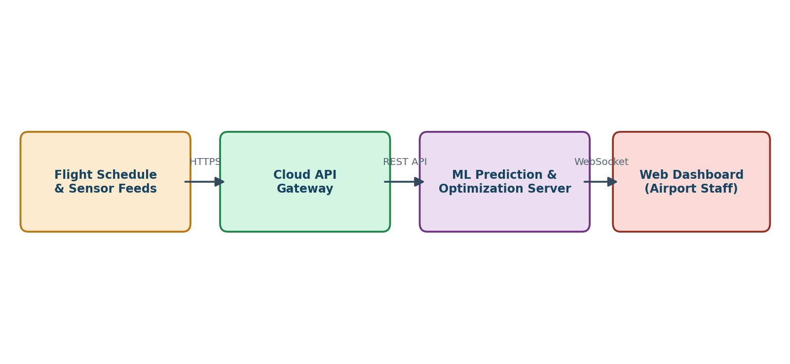
Fig 6.1. System connection and data flow
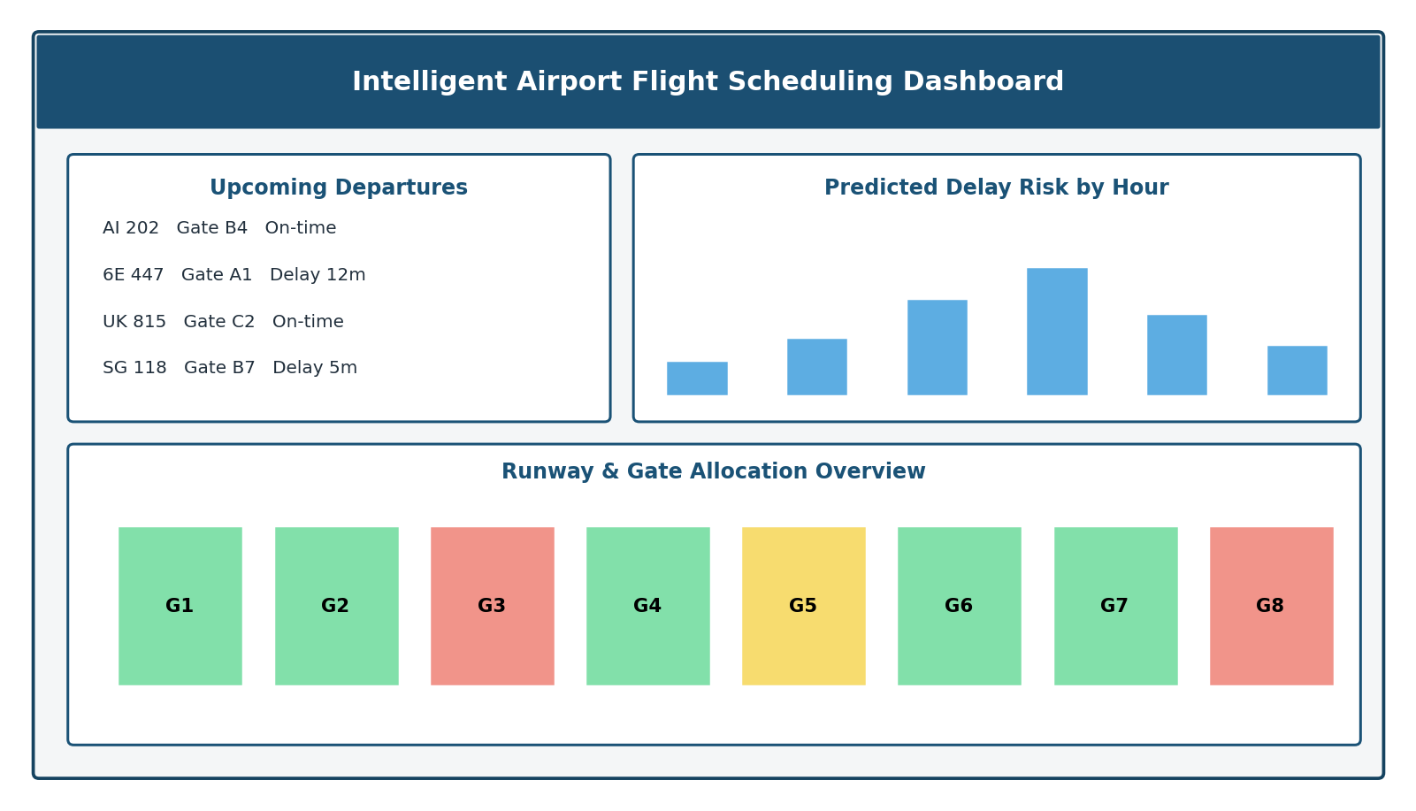
Fig 6.2. Dashboard mockup

Fig 6.3. Predicted delay distribution

